*A BRIEF STATEMENT OF FAITH Apostle’s Creed

**I BELIEVE in God the Father Almighty,**

**Maker of heaven and earth,**

**And in Jesus Christ his only Son our Lord;**

**who was conceived by the Holy Ghost,**

**born of the Virgin Mary, suffered under Pontius Pilate, was crucified, dead, and buried; he descended into hell; the third day he rose again from the dead; he ascended into heaven, and sitteth on the right hand of God the Father Almighty; from thence he shall come to judge the quick and the dead. I believe in the Holy Ghost; the holy catholic Church; the communion of saints; the forgiveness of sins; the resurrection of the body; and the life everlasting. Amen.**

GIFTS, TITHES, AND OFFERINGS

Offertory Music

*The Doxology Hymn #607

*Prayer of Dedication

*The Gloria Patri Hymn #581

PRAYERS OF THE PEOPLE & THE LORD’S PRAYER

*Going in God’s Name*

*CHARGE & BENEDICTION

*OUR CLOSING RESPONSE "Grace, Love, and Fellowship" Tom Fettke

**May the Grace of Christ our Savior, and the Love of God, our Father, and the Fellowship of the Spirit be with us. May the Grace of Christ our Savior, and the Love of God, our Father, and the Fellowship of the Spirit be with us – forever, and ever, forevermore.** (Used by permission - Lic.#720114)

*POSTLUDE *Page 3*

**Worship**

Irene McCarthy (Moderator), Pattie Stanley

**Buildings & Grounds**

Muriel Palmgren (Moderator), Walter Barnes

**Congregational Care**

Muriel Palmgren (Moderator), Irene McCarthy

**Budget/Finance**

Rick Stanley (Moderator), Denyse Schomaker (Treasurer)

**Daycare & CDC Committee**

Lisa Jennings (Moderator), Rachel Bobadilla

**Personnel**

Rachel Bobadilla (Moderator), Susan Reece

**Stewardship & Mission Committee**

Irene McCarthy/Dena Jackson (Moderators), Dolly Hutchinson

**Today’s Worship Leaders**

Rev. David Watson

Jared McCarthy- Liturgist

Gloria Cuadrado - Music Director

**METAIRIE RIDGE PRESBYTERIAN CHURCH SCHOOLS**

Day Care Center

Keri Mercer, Director

(504) 831-2887

Mon. - Fri. 7am-6pm

6 weeks - 2yrs.

metridgedaycare@gmail.com

Child Development Center

Darlene Evans, Director

(504) 833-9463

M - W- F 9am-2:30pm

12 months (walking) - 4yrs.

darlene@metairieridgepc.org

*

BLBLESSING,

**Announcements**

We're glad you came to join us in worship today!  
You are very welcomed in this place.

*Please take a moment and fill out the red attendance pad.*

Both Schools re-opened this past week, and the staff at MRPC is back to regular office hours.

Sunday School is continuing with digital meetings. However, the day and time could potentially change. The church office will communicate any changes to you.

All other fellowship activities, and gatherings are not taking place until further notice.

*ASSURANCE OF PARDON  *Acts 1: 6-14*

Who is in a position to condemn?

**Only Christ, and Christ died for us, Christ rose for us, Christ reigns in power for us, Christ prays for us.**

Anyone who is in Christ is a new creation.

**The old life has gone; a new life has begun.**

Friends, believe the gospel.

**In Jesus Christ, we are forgiven.**

*CONGREGATIONAL RESPONSE *Hymn #286*

**Breathe on me, Breath of God;**

**Fill me with life anew,**

**That I may love what thou dost love,**

**And do what thou wouldst do.**

*The Word*

SCRIPTURE READING Acts 1:6-14 Page 1637

CHORAL ANTHEM

SCRIPTURE READING John 17: 1-11 Page 1627

The Word of the Lord.

**Thanks be to God**.

SERMON “In the World” Rev. David Watson

*Responding to the Word*

P*age 2*

**METAIRIE RIDGE PRESBYTERIAN CHURCH SESSION**

Rev. David Watson, Moderator Jan Allen – Clerk of Session

Denyse Schomaker – Treasurer

**Class of 2020** **Class of 2021** **Class of 2022**

Dena Jackson Jan Allen Lisa Jennings

Muriel Palmgren Rachel Bobadilla Susan Reece

Rick Stanley Irene McCarthy



**CALENDAR FOR MAY 24TH – JUNE 10TH, 2020**

**SUNDAY, MAY 24TH 2020**

9:00AM- Sunday School (Digital Platform-Zoom)

10:30AM- Worship

SUNDAY, MAY 31ST 2020

9:00AM- Sunday School (Digital Platform-Zoom)

10:30AM- Worship

TUESDAY, JUNE 2ND 2020

9:00AM- Presbytery Meeting (Zoom)

SUNDAY, JUNE 7TH 2020

9:00AM- Sunday School (Digital Platform-Zoom)

10:30AM- Worship

WEDNESDAY, JUNE 10TH 2020

6:00PM Stated Session Meeting (Fellowship Hall)

May 24th, 2020

10:30a.m. Worship

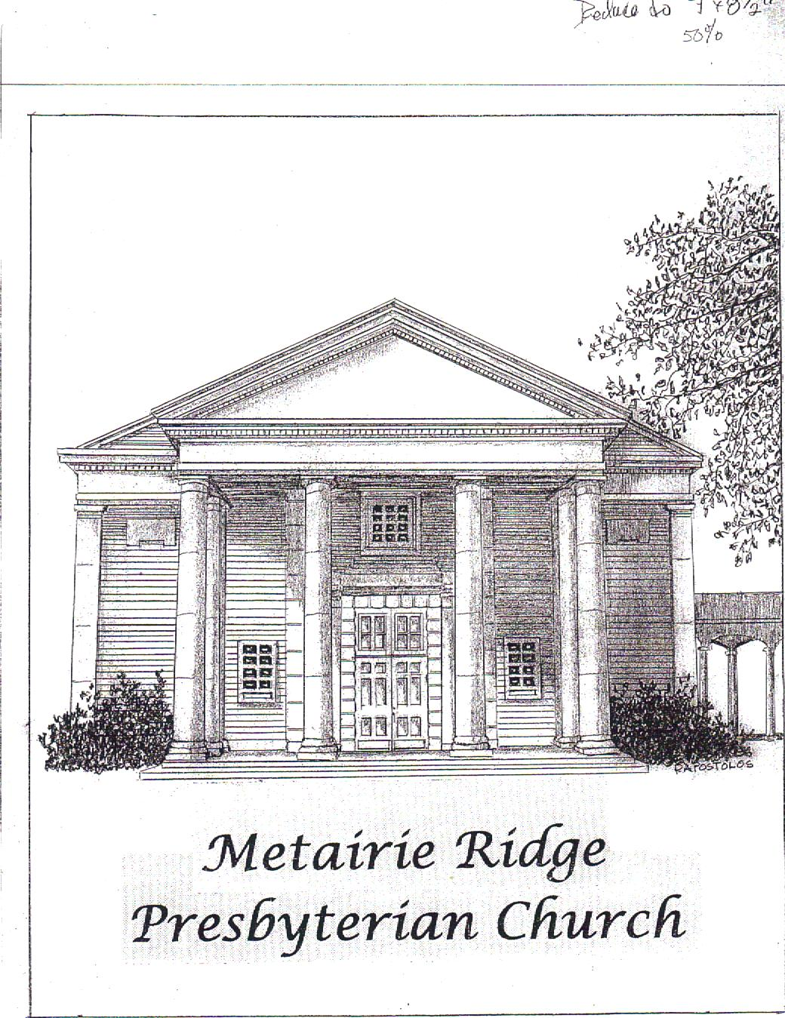

"Continuous effort - not strength nor intelligence -- is the key to unlocking our potential."

**Winston Churchill**

Metairie Ridge Presbyterian Church

Sanctuary: Corner of Codifer St. at Phosphor Avenue

Office & Mailing: 215 Phosphor Avenue, Metairie, LA 70005-3752

Office Hours: Monday-Friday 8am-12pm

Church Office Phone: 833-6357/833-6358

Office Fax: 833-1419

Website: www.metairieridgepc.org

STAFF

Rev. David Watson, B.C.C., Pastor

(email: [David.Watson@metairieridgepc.org](mailto:David.Watson@metairieridgepc.org))

(Please Schedule appointment- Mon-Thrus.)

Lindsay Reine, Administrator Assistant

(email: [churchadministrator@metairieridgepc.org](mailto:churchadministrator@metairieridgepc.org))

(504)833-6357 Monday – Friday 8am-12pm

Jaynie Owen, Financial Assistant (email: [jaynie.owen@gmail.com](mailto:jaynie.owen@gmail.com))

(Mon,Wed,&Fridays 9:30-12pm)

Gloria Cuadrado, Organist/Choir Director (email: [thecuadrados@aol.com](mailto:thecuadrados@aol.com))

Barbara Joseph, Sexton

Members & Friends in Our Thoughts & Prayers

Eleanor Schomaker,

Susan Acosta, Meghan Bollinger, Margaret G. Boston,

Willie Bourgeois, Susan Condit, Woody Crews, Audrey DeLucca, Claire DeLucca, Bennie Doris, Felix Jackson, Bianca Joseph,

Steve Johnson, Jewel Kathmann, Elizabeth La France,

Beverly Morris, Taylor Morris III, Louis Nelson, Joe Nesanovich, Claire Parker, Alma Ray, Bertha Scharfenstein,

Christine Washington, Nicole Wenck, Rose White,

Chris Wyckoff, Virginia Wyckoff

*(Please call or email the church office with any updates you may have to this prayer list.)*

**Transfiguration of the Lord**

*\*The Congregation is invited to rise as able.*

Acts 1: 6-14 John 17: 1-11

*The Gathering*

PRELUDE

GREETING & ANNOUNCEMENTS

INTERLUDE

*You are invited to use this time for Scripture, prayer, and meditation.*

*CALL TO WORSHIP

One: Let us be joyful before God! Let us be jubilant this day.  
**All: We will sing praises to God’s holy name.**

One: Let us lift up a song to the One who rides upon the clouds,

**All: For God also protects orphans and widows, and gives the desolate a home.**

One: Sing to God, O nations of the earth;

**All: We will sing praises to the Lord, our God!**

PRAYER OF THE DAY

PRAYER OF CONFESSION

## God of our days and all the days to come,

## we confess that we feel lost, waiting for your promised redemption in such uncertain times. You made us for unity in community, yet we have nursed grievances and settled for unresolved tensions. You commissioned to be witnesses to Christ’s ministry, yet we find it hard to share our experience of your love and grace with others. Forgive us for accepting disunity, instead of working through differences. Forgive us for failing to share the good news of Christ’s love, even with those closest to us. Amen

*(Silent confession)*

We bring our prayers to you in the name of Jesus Christ our Lord,

who lives and reigns with you in the unity of the Holy Spirit, one God, forever and ever. **Amen.** *Page 1*