*A BRIEF STATEMENT OF FAITH Apostle’s Creed

**I BELIEVE in God the Father Almighty,**

**Maker of heaven and earth,**

**And in Jesus Christ his only Son our Lord;**

**who was conceived by the Holy Ghost,**

**born of the Virgin Mary, suffered under Pontius Pilate, was crucified, dead, and buried; he descended into hell; the third day he rose again from the dead; he ascended into heaven, and sitteth on the right hand of God the Father Almighty; from thence he shall come to judge the quick and the dead. I believe in the Holy Ghost; the holy catholic Church; the communion of saints; the forgiveness of sins; the resurrection of the body; and the life everlasting. Amen.**

GIFTS, TITHES, AND OFFERINGS

Call for the Offering

Prayer of Dedication

PRAYERS OF THE PEOPLE & THE LORD’S PRAYER

*Going in God’s Name*

*CHARGE & BENEDICTION

*POSTLUDE

*Page 3*

**Worship**

Irene McCarthy (Moderator), Pattie Stanley

**Buildings & Grounds**

Muriel Palmgren (Moderator), Walter Barnes

**Congregational Care**

Muriel Palmgren (Moderator), Irene McCarthy

**Budget/Finance**

Rick Stanley (Moderator), Denyse Schomaker (Treasurer)

**Daycare & CDC Committee**

Lisa Jennings (Moderator), Rachel Bobadilla

**Personnel**

Rachel Bobadilla (Moderator), Susan Reese

**Stewardship & Mission Committee**

Irene McCarthy/Dena Jackson (Moderators), Dolly Hutchinson

MRPC Committees

**Today’s Worship Leaders**

Rev. David Watson

Jared McCarthy - Liturgist

Gloria Cuadrado - Music Director

**METAIRIE RIDGE PRESBYTERIAN CHURCH SCHOOLS**

Day Care Center

Keri Mercer, Director

(504) 831-2887

Mon. - Fri. 7am-6pm

6 weeks - 2yrs.

metridgedaycare@gmail.com

Child Development Center

Darlene Evans, Director

(504) 833-9463

M - W- F 9am-2:30pm

12 months (walking) - 4yrs.

darlene@metairieridgepc.org

*

BLBLESSING,

**Announcements**

We're glad you came to join us in worship today!  
You are very welcomed in this place.

*Please take a moment and fill out the red attendance pad.*

If you missed any of the Sermons from this year’s Summer Series, view them on the Media Page on the Church’s Website.

*www.metairieridgepc.org*

The Sunday School Class is meeting in Fellowship Hall at 9:00 AM every Sunday. There is still the option to meet over the phone via Conference Call for those who would prefer.

If you would like to join, please contact the Church Office.

There will be a Guest Preacher on Sunday, August 9th.

All other fellowship activities and gatherings are not taking place until further notice.

*ASSURANCE OF PARDON  *John 20: 19-23*

Who is in a position to condemn?

**Only Christ, and Christ died for us, Christ rose for us, Christ reigns in power for us, Christ prays for us.**

Anyone who is in Christ is a new creation.

**The old life has gone; a new life has begun.**

Friends, believe the gospel.

**In Jesus Christ, we are forgiven.**

*The Word*

SCRIPTURE READING Romans 8: 26-39 Page 1702

CHORAL ANTHEM

SCRIPTURE READING Matthew 13: 31-45 Page 1471

The Word of the Lord.

**Thanks be to God**.

SERMON “No Matter What” Rev. David Watson

*Responding to the Word*

Page 2

P*age 2*

**METAIRIE RIDGE PRESBYTERIAN CHURCH SESSION**

Rev. David Watson, Moderator Jan Allen – Clerk of Session

Denyse Schomaker – Treasurer

**Class of 2020** **Class of 2021** **Class of 2022**

Dena Jackson Jan Allen Lisa Jennings

Muriel Palmgren Rachel Bobadilla Susan Reese

Rick Stanley Irene McCarthy

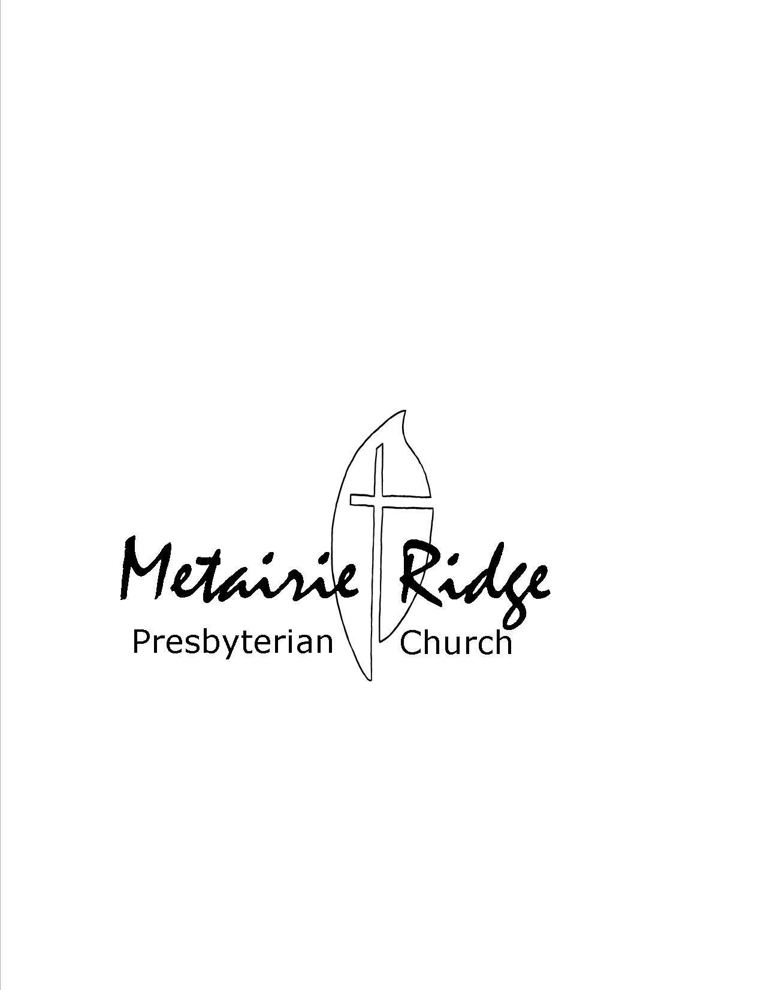

**CALENDAR FOR JUly 26th, 2020 – Aug 2nd**

**SUNDAY, July 26th 2020**

9:00AM- Sunday School

10:30AM- Worship

**SUNDAY, August 2nd, 2020**

9:00AM- Sunday School

10:30AM- Worship

**SUNDAY, August 9th, 2020**

9:00AM- Sunday School

10:30AM- Worship **(Guest Preacher)**



July 26th, 2020

10:30a.m. Worship

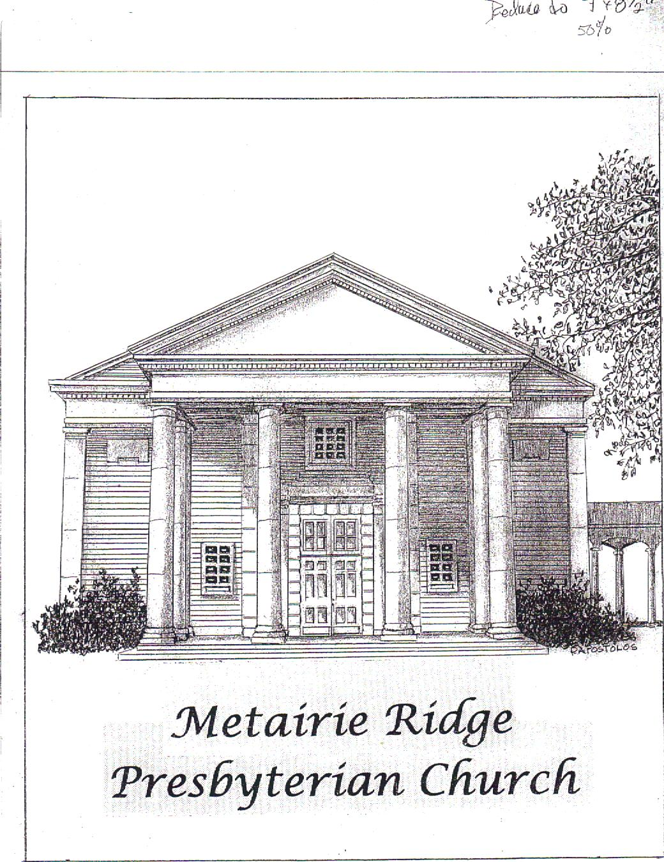 

"Remember who you are. Don’t compromise for anyone, for any reason. You are a child of the Almighty God. Live that truth." **Lysa Terkeurst**

Metairie Ridge Presbyterian Church

Sanctuary: Corner of Codifer St. at Phosphor Avenue

Office & Mailing: 215 Phosphor Avenue, Metairie, LA 70005-3752

Office Hours: Monday-Friday 8am-12pm

Church Office Phone: 833-6357/833-6358

Office Fax: 833-1419

Website: www.metairieridgepc.org

STAFF

Rev. David Watson, B.C.C., Pastor

(email: [David.Watson@metairieridgepc.org](mailto:David.Watson@metairieridgepc.org))

(Please Schedule appointment- Mon-Thurs.)

Lindsay Reine, Administrator Assistant

(email: [churchadministrator@metairieridgepc.org](mailto:churchadministrator@metairieridgepc.org))

(504)833-6357 Monday – Friday 8am-12pm

Jaynie Owen, Financial Assistant (email: [jaynie.owen@gmail.com](mailto:jaynie.owen@gmail.com))

(Mon,Wed,& Fridays 9:30-12pm)

Gloria Cuadrado, Organist/Choir Director (email: [thecuadrados@aol.com](mailto:thecuadrados@aol.com))

Barbara Joseph, Sexton

Members & Friends in Our Thoughts & Prayers

Kayla Peterson, Karen Eigenbrod, Felix Jackson,

Jewel Kathmann, Virginia Wyckoff

*(Please call or email the church office with any updates you may have to this prayer list.)*

**8th Sunday after Pentecost**

*\*The Congregation is invited to rise as able.*

Romans 8: 26-36 Matthew 13: 31-45

:

*The Gathering*

PRELUDE

GREETING & ANNOUNCEMENTS

INTERLUDE

*You are invited to use this time for Scripture, prayer, and meditation.*

*CALL TO WORSHIP

One: Give thanks to the Lord and call on God’s name!

**All: We will praise our God and tell of all God’s wonderful works.**

One: Let the hearts of those who seek the Lord rejoice.

**All: We will give glory to God’s holy name!**

One: Seek the Lord, God’s strength and presence continually.

**All: We will remember God’s mercy and justice in worship and praise.**

PRAYER OF THE DAY

PRAYER OF CONFESSION

**Merciful God,**

**We confess that we feel more comfortable with the way things are, rather than live out the challenges we meet in Jesus. Tempted by the promises of our culture, we rely on the status quo to protect and prosper some but not all. Turning away from the cries of the hurting, we fail to stand up for the justice they seek. Afraid to speak of our faith and hope in you, we remain silent and complacent. Forgive us all the ways we let you down. Amen.**

*(Silent confession)*

We bring our prayers to you in the name of Jesus Christ our Lord,

who lives and reigns with you in the unity of the Holy Spirit, one God, forever and ever. **Amen.** *Page 1*